Kenya County Profiles –Second round

**Counties involved**: 16

**Number of deliveries**: 2 (first: 20 Feb 2017; second: 20 Mar 2017)

**First**: Bomet, Kericho, Kakamega, Uasin Gishu, Keiyo-Marakwet, Machakos, Kisumu, Kajiado

**Second**: Baringo, Laikipia, Tharaka, Lamu, Marsabit, Isiolo, Wajir, Mandera

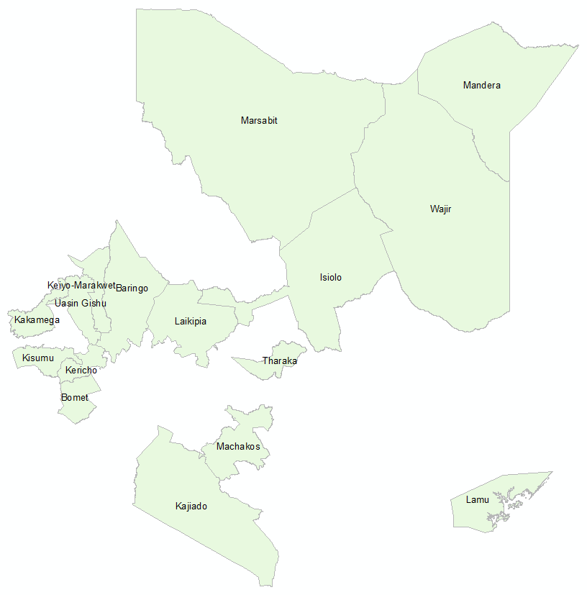

Fortunately for the first delivery of 8 counties, all of them are small except only one “big” county (Kajiado). On the other hand, for the second round we have to face with the biggest ones (Marsabit, Isiolo, Wajir and Mandera). That means more time of processing especially in the Bias-Correction part.

**Some R-scripts new to be updated in order to run the process automatically**. It will help Jaime to understand and run the stuff quickly and efficiently if it’s necessary.

Climate data resampled for Kenya are already done. It’s necessary to begin with Bias-Correction for new counties.

Soil data resampled for Kenya are already done.

~~CHIRPS data should be involved 2016 data?~~

Analysis process

For each county we have to follow next steps:

1. **Processing GCM data: cropping, resampling (data sources: 11 GCMs from CMIP5) (R-script: 00_KACCAL_processing_gcm_information.R) DONE FOR KENYA, it’s not necessary repeat it -OK**
2. **Processing observational data: extracting spatiotemporal data for each specific county (data sources: CHIRPS, Sheffield, ISRIC) (R-script: 00_KACCAL_input_data.R) -OK**
3. **Identify 100-wettest days within January-June and July-December for variables PREC, TMAX, TMIN, SRAD at the present (R-script: 00_KACCAL_input_data.R) -OK**
4. Do quantile-mapping bias correction for GCM data using as reference observational data (R-script: 01_KACCAL_bc_quantile-mapping.R) – only corer sin modificaciones
5. Identify 100-wettest days within January-June and July-December for variables PREC, TMAX, TMIN, SRAD at the future (R-script: 02_KACCAL_season_indexes_future.R) – es igual al paso 3 Jaime
6. Calculate agro-climate indices for the present (R-scripts: 03-04_KACCAL_climatic_indices_current.R)[1]
7. Calculate agro-climate indices for each GCM and RCP combination at the future (R-scripts: 05-06_KACCAL_climatic_indices_future.R)
8. Get statistics from agro-climatic indices calculated (R-scripts: 08_KACCAL_get_statistics_from_climatic_indices.R and 08_KACCAL_get_statistics_from_climatic_indices2_LGP.R) Harold unificará los R-scripts
9. Do graphics for publishing (R-script: 08_KACCAL_nicePlots4Docs.R)

|  |  |  |  |  |  |  |
| --- | --- | --- | --- | --- | --- | --- |
| **Date** | **County** | **Pixels** | **Pixels data** | **BC-quantile** | **Climatic indexes** | **Scenarios** |
| 23 Jan 2017 | Bomet | 168 | 114 | Processing |  |  |
| 23 Jan 2017 | Kericho | 143 | 93 | Processing |  |  |
| 23 Jan 2017 | Kakamega | 256 | 135 | Processing |  |  |
| 23 Jan 2017 | Uasin Gishu | 285 | 143 | Processing |  |  |
| 23 Jan 2017 | Keiyo-Marakwet | 253 | 131 | Processing |  |  |
| 23 Jan 2017 | Machakos | 399 | 254 |  |  |  |
| 23 Jan 2017 | Kisumu | 152 | 111 |  |  |  |
| 23 Jan 2017 | Kajiado | 1677 | 789 |  |  |  |
| 20 Feb 2017 | Baringo | 760 | 410 |  |  |  |
| 20 Feb 2017 | Laikipia | 552 | 366 |  |  |  |
| 20 Feb 2017 | Tharaka | 200 | 112 |  |  |  |
| 20 Feb 2017 | Lamu | 432 | 265 |  |  |  |
| 20 Feb 2017 | Marsabit | 4224 | 2583 |  |  |  |
| 20 Feb 2017 | Isiolo | 2288 | 934 |  |  |  |
| 20 Feb 2017 | Wajir | 2898 | 1939 |  |  |  |
| 20 Feb 2017 | Mandera | 1764 | 917 |  |  |  |

1. LGP: Length of Growing Period